- A car moving with a velocity 16 m s⁻¹ towards east changes its velocity to 20 m s⁻¹ towards south in a time of 2 seconds as shown in Fig. 1.1.
16 m s⁻¹


20 m s⁻¹

Fig. 1.1

  - Find the magnitude of the change in velocity of the car.

Change in velocity = ……………….…… ms⁻¹ [2]

  - Find the acceleration of the car.

Acceleration = …………….….… ms⁻² [1]

  - Distinguish between a scalar and a vector quantity.

……………………………………………………………………………………..

……………………………………………………………………………………..

…………………………………………………………………………………..[2]

  - If the car’s speed is still 16 ms⁻¹ after turning, is it accelerating? Explain.

……………………………………………………………………………………..

……………………………………………………………………………………..

………………………………………………………………………………… [2]

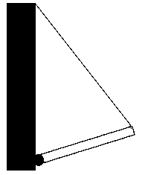
- A square uniform trapdoor is shown in Fig. 2.1. It is hinged on a wall and is held open at an angle to the horizontal by means of a rope attached as shown.
Wall
Rope

Trap door

Hinge

Fig. 2.1

- On the diagram, mark with an arrow labeled W, the weight of the trapdoor. [1]

- Mark on the diagram an arrow labeled T, to represent the tension of the rope acting on the trapdoor. [1]

- Finally draw an arrow labeled R, to represent the force on the trapdoor due to the hinge. [1]

3 The Young’s modulus, Y of a copper wire can be represented by the equation:

E = 4MgL
πD²e

Where M is the mass of the wire
g is the acceleration of gravity
L is the original length of the wire
D is the diameter of the wire
e is the change in length of the wire

- (i) What are the base S.I. units for Young’s modulus?

Units = …………………..….[2]

(ii) Suggest another physical quantity which has the same units.

…………………………………………………………………………………..[1]

- The value of the Young’s modulus of copper is 1.2 x 10¹¹ N m⁻² and the % uncertainties of M is 3 %, L = 2 %, e =1 % and D = 2 %. Find the uncertainty in the value of E and write down the answer together with its uncertainty.

E =..…………. ± …………. N m⁻² [3]

- Distinguish between elastic and plastic deformation.

……………………………………………………………………………………..

………………………………….…………………………………………………..

………………………………………………………….……………….……… [2]

- Explain why Young Modulus (E) is a better quantity to represent elasticity than force constant (k).

…….………..………………………………………………………………………

…….………………………………………………………..………………………

..………………………………………………………………………………….[2]

In Fig. 3.1, a bomb is dropped on an enemy target by an aeroplane flying with a horizontal velocity of 180 km hr⁻¹ and at a height of 490 m.
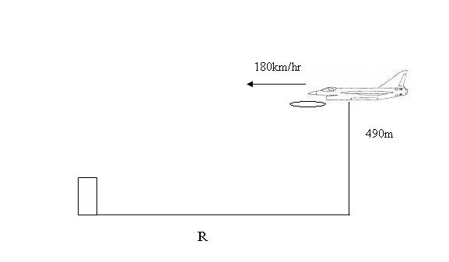
Fig. 3.1

R
Target

R

At what distance R must the aeroplane be at the time of dropping the bomb so that it may directly hit the target? Neglect the dimensions of the target.

R = ………………….. m [3]

5 (a) State the principle of conservation of momentum.
………………………….……………………………………………………………..

………………………….……………………………………………………….…..[2]

Fig. 4.1 below shows a block of wood of mass, m = 1 kg attached to a string of length, L = 1 m.

1 m
1 kg
Bullet

0.02 kg
Fig. 4.1

It is released from a height of 1m from its equilibrium position. At its lowest point, it is hit by a bullet of mass 0.02 kg with a velocity of 340 m s⁻¹ traveling in the opposite direction. The bullet becomes lodged in the block.

- Find the speed, u of the block when it drops to the lowest point.

u = ………………. ms⁻¹ [2]

- Find the velocity, v of the bullet-block mass after impact.

v = ………………..ms⁻¹ [2]

(iii) Will the combined mass regain its original release height? Show by way of calculation.

…………………………………………………………………………….

…………………………………………………………………………. [3]

- In Fig. 5.1, the circuit can be used as a lightmeter. A lightmeter measures the intensity of light.

V

6.0 V

10 kΩ

Fig. 5.1

- The resistance of a light-dependent resistor (LDR) changes as light intensity increases. The maximum value of resistance of this LDR is 950 kΩ. A very high resistance voltmeter is connected across the 10 kΩ resistor. What is the reading on the voltmeter for this resistance?

Voltmeter reading = ……………V [2]

- For this lightmeter, the voltmeter is connected across the 10 kΩ resistor, rather than the LDR. Explain how the readings on the voltmeter enable this circuit to be used as a lightmeter.

…….………………………………………………………………………………

…….………………………………………………………………………………

…….………………………………………………………………………………

…….………………………………………………………………………………

…….……………………………………………………………………………[4]

- The graphs in Fig. 6.1 show the variation of current with potential difference for a filament lamp and for an ohmic resistor

1
2
3
4
6
7
5
8
9
0.1
0.2
0.3
0.4
0.6
0.5
I/A

V/V

Fig. 6.1

- Label one graph L to represent the lamp and the other graph R to represent the resistor. [2]
- The lamp and resistor are connected in series as shown in Fig. 6.2. There is current of 0.5 A.
L
R

Fig. 6.2

Use the graph to find the total potential difference, V_{T} across the combination.

V_{T} = ……………………… V [2]

- In Fig. 7.1, a 12 V battery is recharged by passing a current of 5.0 A through it in the reverse direction using a 15 V battery charger. The internal resistance of the charger and the battery are 0.56 Ω and 0.04 Ω respectively. The circuit used is shown below.

0.04 Ω
V

12 V
battery
15 V

Battery
charger 0.0.56 Ω

charging current
5.0 A
Fig. 7.1

  - The terminal p.d. across the battery charger is found by solving the following equation:

Terminal p.d. = 15 V – (5.0 A x 0.56 Ω )

Determine the reading, V on the voltmeter.
V = …………… V [1]

- Write an equivalent equation for the terminal p.d. across the battery.

……………………………………………………………………..…… [1]

- Calculate the rate at which energy is being wasted, P during the recharging process.

P = ……………. W [2]

- Hence determine the efficiency, E of the recharging process.

E = ……………… % [2]

- A CD player uses a laser that emits radiation of wavelength 790 nm.

A student suggests setting up this laser to observe a two-slit interference pattern by shining it at a screen through a double slit. Why would the student not be able to see any fringes?
.………………………………………………………………………………… [1]

  - A laser that emits radiation of wavelength 790 nm is directed at a double slit with a suitable detector 1.2 m from the slit. The slit spacing is 0.24 mm. How far apart are the fringes which correspond to maximum readings on the detector?

Fringe separation = …………………[3]

  - A stationary wave of amplitude 4.0 cm is produced by the superposition of two progressive waves that travel in the opposite directions.

(i) Define the term amplitude.

…………………………………………………………………………………[1]

(ii) The graph in Fig. 8.1 shows the positions of the stationary wave and of one of the two progressive waves at a particular instant. Apply the principle of superposition to determine the displacement of the other progressive wave at positions A, B and C on the distance axis at this same instant.

Displacement at A = ……….….…cm

Displacement at B = …………..…cm

Displacement at C = ……….….…cm [3]

(iii) Hence plot these displacement values and one complete wavelength of this progressive wave on Fig. 8.1. [3]
Displacement/cm
Distance / cm
-2
-1.

1
3
2
4
-3
-4
progressive wave
Stationary wave
A
C
B

Fig. 8.1

- Below are the symbols for some nuclei of the element tin.
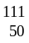 Sn 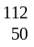 Sn 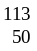Sn 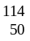 Sn 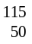 Sn

    - What name is given to different nuclei of this type?

…………………………………………………………………………………[1]

    - Sn decays by beta-plus β emission into Indium (In). Write a balanced nuclear equation for this decay.

…………………………………………………………………………………[1]

    - Which nucleus in the list is most likely to produce the densest material?

…………………………………………………………………………………[1]

